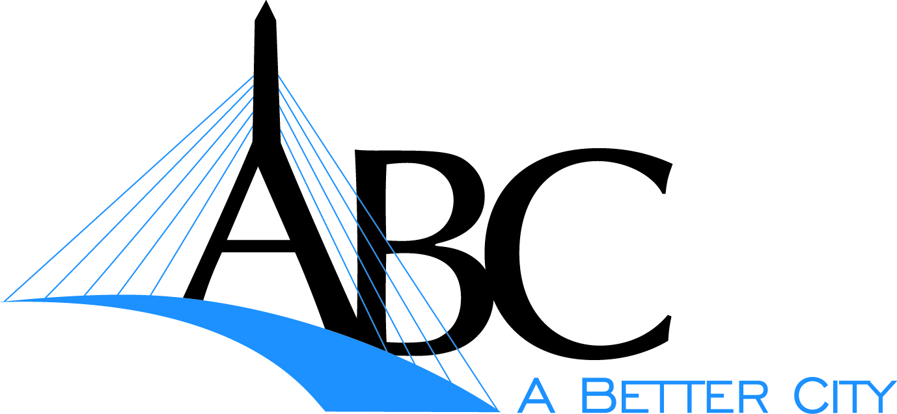 (Insert your logo here)

**For Immediate Release: Date: December XX, 2011**

**A Better City**

Contact: Mihir Parikh

Sustainability Coordinator

Phone: (617) 502-6245

**XXXXX Joins 60+ Businesses in 3rd Annual Environmental Initiative**

***A Better City helps businesses protect their bottom line through it’s2012 Challenge for Sustainability***

**Boston, MA –** XXXX has joined businesses and buildings from across the region in dedicating the next year to increase their sustainability and reduce energy use through participation in the Challenge for Sustainability. A kick-off event on December 15th brought together more than 60 participating businesses at the Atlantic Wharf building on Boston’s waterfront, featuring Evelyn Friedman, Cabinet Chief of Housing and Director of the Department of Neighborhood Development (DND) at the City of Boston and Kathy Loftus, Global Leader, Sustainable Engineering, Maintenance & Energy Management at Whole Foods. Participants in the 2012 Challenge include some of Boston’s largest buildings and progressive businesses, from convention centers to small pizza shops.

The Challenge for Sustainability helps businesses save money by increasing energy efficiency, reducing resource consumption, decreasing solid waste, and reducing overall greenhouse gas emissions. ABC provides participants with hands-on technical assistance, access to energy audits, guidance in developing and implementing a sustainability plan, and connection to a network of sustainability professionals and practitioners for networking and best practices sharing.

Participation for businesses throughout Boston’s Main Streets districts has been made possible through a partnership with the City of Boston and funding from The Boston Foundation. ABC and the City of Boston are targeting small to medium size businesses in all 19 districts, and hope to serve 50 Main Streets businesses in 2012. XXX joins XXX, XXXX, and XXXX from Main Streets businesses that have already signed on to the program representing the XXX district. “We believe our participation in the Challenge for Sustainability will bring us the knowledge and tools we need to receive significant savings while protecting our bottom line,” said XXXXXX, of XXXXXX.

Wade Winters, representing Au Bon Pain in the Challenge states that, “A Better City has been vital in providing the contacts, resources, and data necessary to avoid the red tape and efficiently pursue energy saving initiatives for Au Bon Pain.  The ABC team members provide experiences and information that help others avoid mistakes and pitfalls”.

The Challenge for Sustainability was launched in 2009 by A Better City, a non-profit business association focused on transportation, land development, and environmental initiatives aimed at improving the economic competiveness of Greater Boston.