Employees’ ideas yield savings and a healthier environment.
A Better City recognizes 37 Greater Boston businesses for embracing a holistic approach to sustainability.

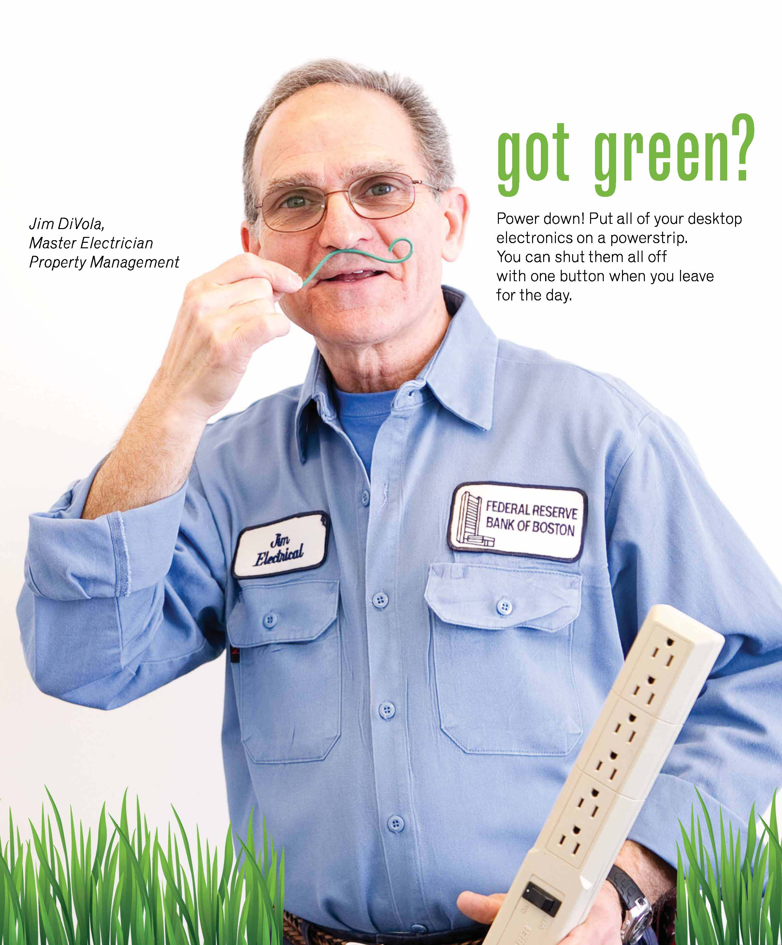
BOSTON, MA – Employees are often the best resource for low cost innovative ideas that can save a company money and improve employee engagement. A Better City’s Challenge for Sustainability is helping organizations in Greater Boston capture these ideas to incorporate sustainable strategies in operations, reduce energy consumption, and lower greenhouse gas emissions. In 2011, the Challenge for Sustainability brought together employees from major building owners, tenants, and cultural institutions representing more than 20 million square feet, to share best practices, learn about financial incentives, break through barriers, vet vendors, and develop sustainable initiatives.

“Got Green?”
Janice Kimsey gets to work every day in an iconic building on the Fort Point Channel, where she can take her lunch break on Boston’s oldest and arguably most beautiful green roof. The building received the prestigious LEED Gold for Existing Buildings rating from the US Green Building Council in 2009, and is a green leader in its operations. But Janice is always looking for ways to engage employees more in sustainable activities.

Taking inspiration from the ‘Got Milk?’ campaign, Janice coordinated a photo shoot this year with staff from across various departments and used her keen design eye to create a series of “Got Green?” ads. Each employee sports a job tool as a green “mustache”: an employee from food services holds a spear of asparagus, an electrician an artfully twisted strand of wiring, an IT staffer holds a green thumb drive, the grounds chief wears a rose mustache. Each person promotes a relevant green tip like “Store documents electronically” and “Make purchases from green suppliers.” The poster series was mounted in a high traffic area of the building, and engendered a lot of comment – and enjoyment. Engagement campaigns like Janice’s change people’s behavior, which is ultimately the test of truly high performing environmental buildings.

Operation Blind Drop
At Equity Office’s 222 Berkeley Street in the Back Bay, Jim Green, Vice President of Engineering at Hines, is focused on improving the operations of the building. At 22 stories, the building not only has amazing views but great natural daylight. That’s good for reducing lighting and heating during the winter, but bad for air conditioning in the summer. Jim knew from home that simply closing the blinds can save tremendously on electric bills, but how could he do this for the whole building?

Jim coordinated with all the east facing tenants of the building to lower their blinds at the end of the day. If they forgot, the housekeeping staff would do it for them. Each summer morning, the building’s chillers would turn on at 8:30 instead of 7:00, saving the building and tenants approximately $6,000 per year and enough electricity to power two single-family homes. The initiative was coined “Operation Blind Drop” and not only did it remain at 222 Berkeley, but Hines has rolled out to many other properties across the U.S.

Recognizing Success
On March 12th, A Better City recognized the achievements of the 2011 class at the Challenge Awards. The total portfolio’s annual reductions included 8,500,000 kWh of electricity equivalent to $425,000 or 730 homes’ power; and, an annual water reduction of 11,000,000 gallons of water, equivalent to 2100 Olympic pools!

Nixon Peabody LLP, a law firm and first-year participant in the Challenge, received the Highest Score Award (84%) for 2011. The Most Improved Award went to Peabody Office Furniture for an improvement of 267%! And the Greatest Energy Reduction Award goes to TRO Jung|Brannen architects, for achieving a 23% reduction in electricity per square foot. Last and certainly not least, in keeping with the spirit of the Challenge, participants vote on who of their cohorts makes the program a success by sharing practices or inspiring them and it should not come as any surprise that the 2011 class voted Jim Green of Hines for the Peer Award.

About the Challenge for Sustainability
Funded by the Barr Foundation and The Boston Foundation, A Better City’s Challenge for Sustainability is designed to leverage the private sector’s ability to influence change and make Greater Boston a leader in energy efficiency and sustainable business practices. The program challenges businesses, institutions, and building owners to meet a broad range of sustainability standards and practices within energy efficiency, water efficiency, transportation, waste reduction & management, cleaning & toxics, program implementation & policies, purchasing, and renewable energy in order to reduce environmental impacts and improve the economic competitiveness and readiness of businesses throughout the region.

Challenge is entering its third year in 2012 and is offered free of charge to members of A Better City or for a subsidized or small rate to the City of Boston Main Streets’ businesses. Between the two groups this year, there are 68 properties, 30 million square feet and 60,000 employees.

About A Better City
ABC is an independent, membership-based organization that works to improve the economic competitiveness and quality of life of the Greater Boston region by advancing significant transportation, land development and environmental policies, projects and initiatives. ABC mobilizes the business community to collaborate with both civic and government sectors to take action on challenges facing the region today and into the future.

# # #

